## EdWest

**Semester 1 Examination, 2018**

##### 

**COMPUTER**

**SCIENCE**

**Unit 1: Year 11 ATAR**

**Marking Guide**

**Section One: Short answer** **40% (76 Marks)**

**Question 1 (4 marks)**

Describe **two** differences between ROM and RAM.

|  |  |
| --- | --- |
| **Description** | **Mark** |
| Detailed description of a difference between ROM and RAM | 2 |
| Limited description of a difference between ROM and RAM | 1 |
| Detailed description of a difference between ROM and RAM | 2 |
| Limited description of a difference between ROM and RAM | 1 |
| Total | 4 |
| Sample answer could include:  ROM is a smaller amount of storage used to hold the boot up system and cannot be changed known as nonvolatile  RAM is much larger amount of storage and is used to hold the applications that the computer is running at the time. It is constantly being changed and is known as volatile. | |

**Question 2 (4 marks)**

Describe **two** differences between a mechanical disk and a solid-state drive (SSD).

|  |  |
| --- | --- |
| **Description** | **Mark** |
| Detailed description of a difference between a mechanical disk and a solid-state drive (SSD) | 2 |
| Limited description of a difference between a mechanical disk and a solid-state drive (SSD) | 1 |
| Detailed description of a difference between a mechanical disk and a solid-state drive (SSD) | 2 |
| Limited description of a difference between a mechanical disk and a solid-state drive (SSD) | 1 |
| Total | 4 |
| Sample answer could include:  SSD - There are no moving parts as information is stored in microchips. Uses less power than to run and is quite expensive.  A mechanical disk - uses a mechanical arm with a read/write head to move around and read information from the right location on a storage platter. Uses more power, quite cheap and tends to get quite hot while running.  Good website to check for more differences <http://www.storagereview.com/ssd_vs_hdd> | |

**Question 3 (4 marks)**

1. Identify the project management concept where this type of activity would occur.

(1 mark)

|  |  |
| --- | --- |
| **Description** | **Mark** |
| Identified correctly that **budgeting** is the project management concept where this type of activity would occur | 1 |
| Total | 1 |

1. Outline the key aspects using data from this image that would help an organisation decide whether this project should proceed. (3 marks)

|  |  |
| --- | --- |
| **Description** | **Mark** |
| Detailed outline of the key aspects | 2 |
| Limited outline of the key aspects | 1 |
| Uses data from the image | 1 |
| Total | 3 |
| The answer can be either way as long as long as it is justified with data from the image.  Sample answer could include:  This is a budget sheet showing the cost of the development and the projected costing and revenue over the next three years. The system is able to pay back within a three-year period.  Some answers may say this is too long as a web site needs to be continually updated, others may say that it is fine and should go ahead. | |

**Question 4 (3 marks)**

1. Identify the type of system development methodology represented in this image.

(1 mark)

|  |  |
| --- | --- |
| **Description** | **Mark** |
| Identified correctly that **protoyping** is the system development methodology represented | 1 |
| Total | 1 |

1. Outline **two** benefits of this type of system development methodology. (2 marks)

|  |  |
| --- | --- |
| **Description** | **Mark** |
| Detailed outline of two benefits of this type of system development methodology | 2 |
| Limited outline of two benefits of this type of system development methodology | 1 |
| Total | 2 |
| Sample answers could include:   1. Allows the organisation to quickly design and test a concept based on their current understanding of what the end user wants. 2. The prototype can be tested by the end user and features can be added or changed depending on feedback. 3. It can normally save money and time developing items that meet the client’s requirements. 4. As can be seen in the image the phone app is being tested by the user to check that the button size and placement is easy to use and that the screen can be accessed. The phone is also able to be handled with one hand. | |

**Question 5 (4 marks)**

A computer system is composed of four parts. Identify these in the following diagram to illustrate how they work together.

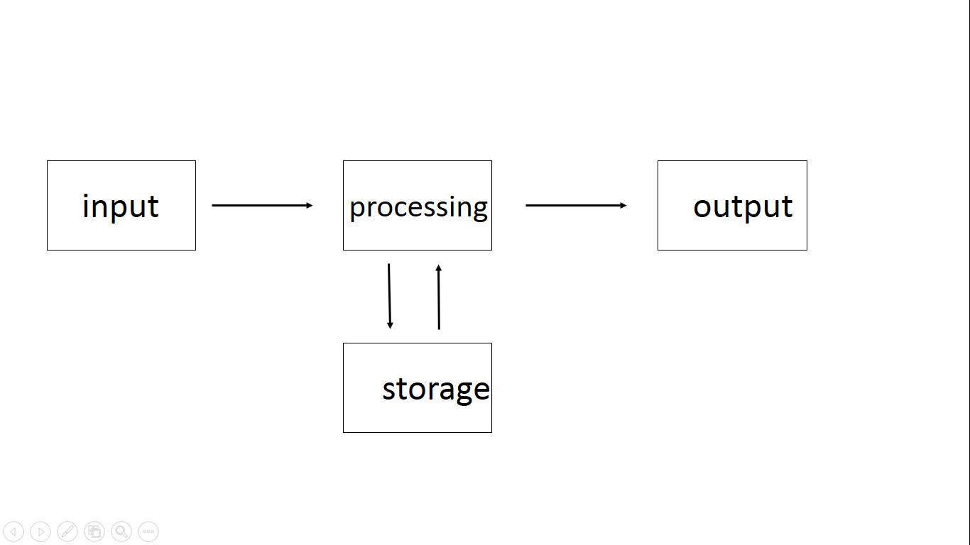

|  |  |
| --- | --- |
| **Description** | **Mark** |
| First box is Input | 1 |
| Middle box is processing or process | 1 |
| End box is Output | 1 |
| Bottom box is storage | 1 |
| Total | 4 |

**Question 6 (3 marks)**

A small company with about 50 PCs had a policy of purchasing one copy of each software program and copying this for each computer. The owner stated that the company had bought it and that they could load it on any computer. A new employee disagreed with this process.

Discuss using your knowledge whether you agree with the owner or employee.

|  |  |
| --- | --- |
| **Description** | **Mark** |
| Highly detailed discussion agreeing with the employee | 3 |
| Detailed discussion agreeing with the employee | 2 |
| Limited discussion agreeing with the employee | 1 |
| Total | 3 |
| Sample answer below  The employee is correct as when you purchase software, you are actually purchasing a license to use it, not the actual software. The license establishes your rights for using the software. Making or using more copies of the software than the license permits is copyright infringement and is "unauthorized use". This is known as end-user piracy. It is always important to check the licence agreement that comes with the software as this will let you know how many computers you can use it on. | |

**Question 7 (2 marks)**

Symmetric encryption is also known as private key encryption and asymmetric cryptograph also known as public key encryption. Outline a key difference between these two types of encryption.

|  |  |
| --- | --- |
| **Description** | **Mark** |
| Detailed outline of a key difference between these types of encryption | 2 |
| Limited outline of a key difference between these types of encryption | 1 |
| Total | 2 |
| Sample answer below  The key difference between these two types of encryption is that symmetric algorithms use the same key for both encryption and decryption. While asymmetric algorithms use different keys for encryption and decryption. | |

**Question 8 (2 marks)**

Spreadsheets use formulas and functions to create calculations.

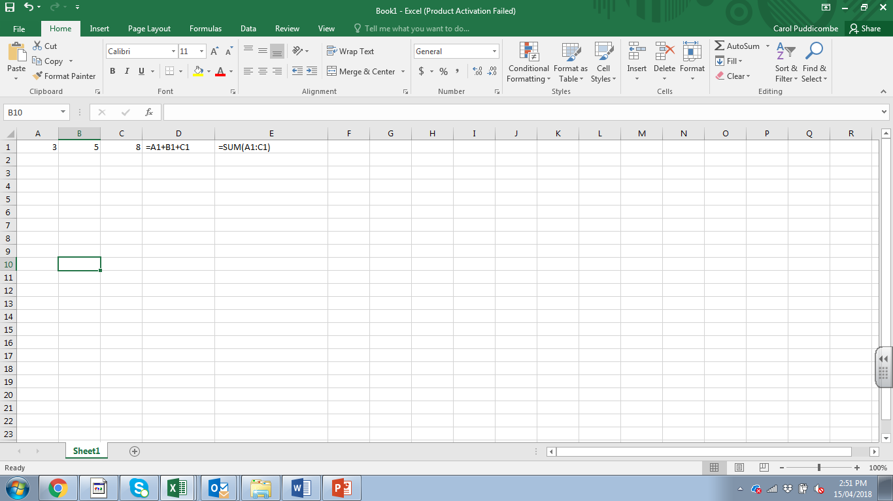

Using information from the image above; describe a function in spreadsheets.

|  |  |
| --- | --- |
| **Description** | **Mark** |
| Detailed description of a function in spreadsheets | 2 |
| Limited description of a function in spreadsheets | 1 |
| Total | 2 |
| Sample answer below  The function that is shown in this image is the SUM function where the cells in A1 to C1 are grouped as a range and added quickly, while the other is a formula adding three cells together individually. A function is a standard routine that has already been established by the spreadsheet for ease of use. | |

**Question 9 (3 marks)**

Use the image below to answer this question.

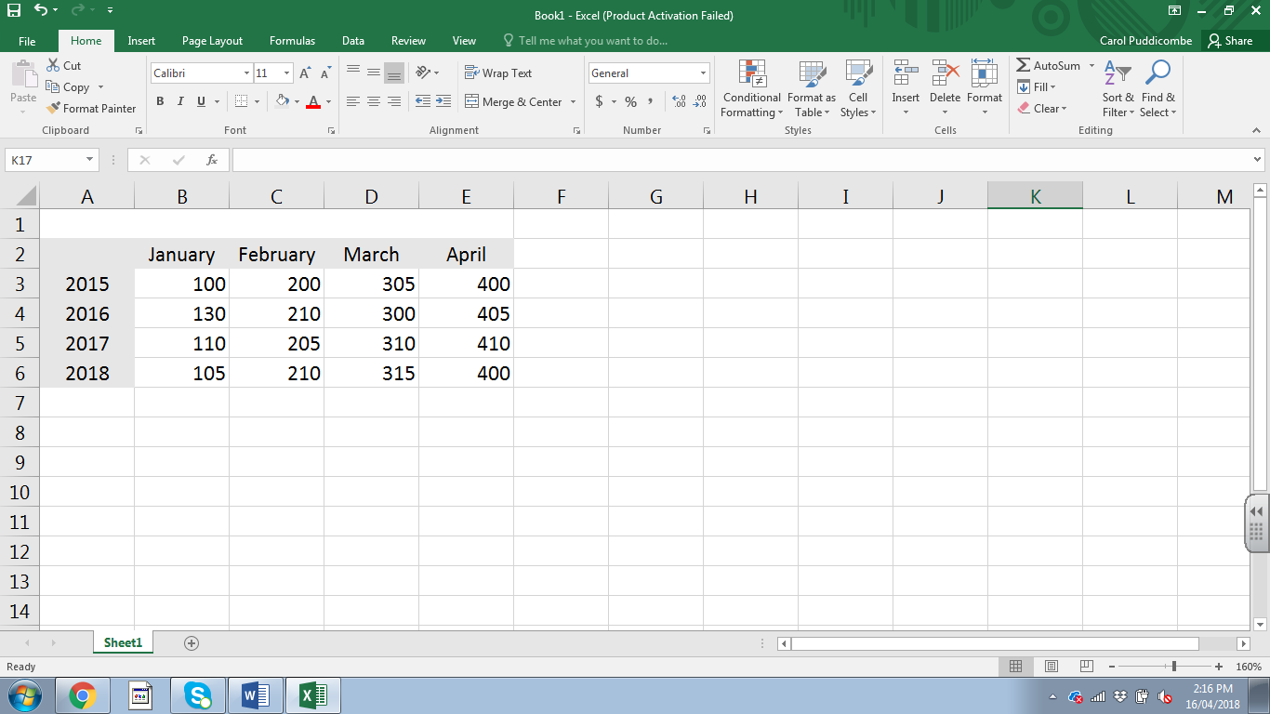

1. Outline the difference between HLookup and VLookup in spreadsheets. (1 mark)

|  |  |
| --- | --- |
| **Description** | **Mark** |
| Outlines the difference between HLookup and VLookup | 1 |
| Total | 1 |
| Sample answer below  HLOOKUP is the exact same function as VLOOKUP, but looks up data that has been formatted by rows instead of columns. | |

1. Identify which lookup you would use to find out the following: (2 marks)

|  |  |
| --- | --- |
| **Description** | **Mark** |
| Identifies Vlookup for the amount in the third column for 2016 | 2 |
| Identifies Hlookup for the amount in the fourth row for March | 1 |
| Total | 2 |

**Question 10 (4 marks)**

Use the image of the entity relationship diagram (ERD) shown below and answer all parts of this question.

1. Identify the entity in this diagram. (1 mark)

|  |  |
| --- | --- |
| **Description** | **Mark** |
| Identifies either Doctor or Patient | 1 |
| Total | 1 |

1. Identify the relationship in this diagram. (1 mark)

|  |  |
| --- | --- |
| **Description** | **Mark** |
| Identifies the sees as the relationship. | 1 |
| Total | 1 |
| Note: Answers may also state the cardinality of M:N however the relationship is the information in the diamond. | |

1. Changes would need to occur with this diagram to illustrate how a relational database could be created. Identify what needs to be changed. (2 marks)

|  |  |
| --- | --- |
| **Description** | **Mark** |
| Detailed identification of what needs to be changed. | 2 |
| Limited identification of what needs to be changed. | 1 |
| Total | 2 |
| Sample answer should include:  The diagram illustrates a many to many relationship with many doctors seeing many patients and many patients seeing many doctors. In order for this to be created in a relational database, an associative entity is required to resolve this moving the M:N to two 1:M’s. The M must be in the associative entity and foreign keys will need to be created. | |

**Question 11 (2 marks)**

Using your knowledge of databases, write a field validation rule where ProductPrice cannot accept a negative number in the space.

|  |  |
| --- | --- |
| **Description** | **Mark** |
| Correctly writes a field validation rule | 2 |
| Some part of the validation rule is correct | 1 |
| Total | 2 |
| Sample answer  Note the answer does not need to have the field name as in a database dictionary the information is aligned with the field. Other answers can be accepted as long as they are logical  ProductPrice > -1 | |

**Question 12 (7 marks)**

Use the image below which represents part of a database indicating the first and second prize winners for a competition.

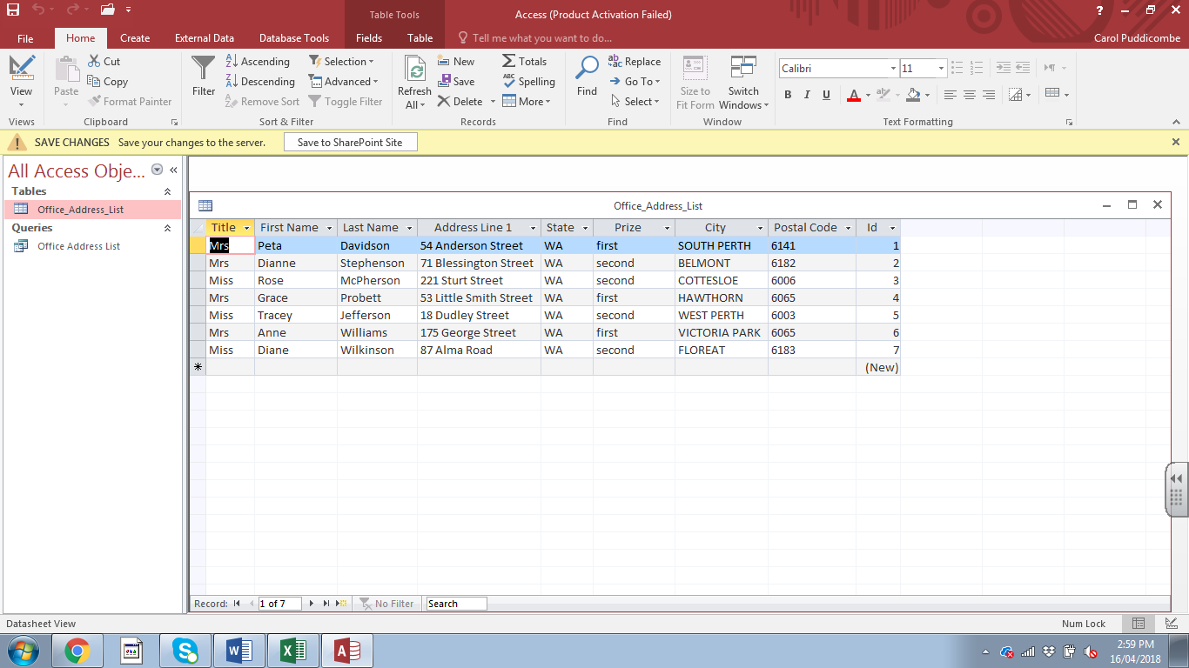

1. Using examples describe each of the four parts of the hierarchical structure of data.

(4 marks)

|  |  |
| --- | --- |
| **Description** | **Mark** |
| Describes the table/entity/relation as the top of the structure with Office_Address_List as the name. | 1 |
| Describes the record/tupple as the next level of the structure highlighting any of the rows. | 1 |
| Describes the field/attribute as the next of the structure highlighting any of the columns. | 1 |
| Describes the character/byte as the last of the structure with any of the field data | 1 |
| Total | 4 |
| Sample answer for field  A data field such as Title holds a single fact or attribute of an entity. |  |

1. Identify which data type you would use for the: (3 marks)

|  |  |
| --- | --- |
| **Description** | **Mark** |
| Identifies Title text(string) correctly | 1 |
| Identifies Id number correctly – some may say Autonumber accept this | 1 |
| Identifies Prize Boolean(true/false) correctly –some may say a dropdown list. | 1 |
| Total | 3 |

**Question 13 (6 marks)**

The following is an example of a trouble shooting procedure for a mouse that does not work.

1. Check USB connector
2. Plug into different USB port
3. Try different mouse
4. Try mouse on a different computer
5. Check software
6. Call Help desk

Document a trouble shooting procedure for someone having difficulty printing a document from a computer.

|  |  |
| --- | --- |
| **Description** | **Mark** |
| Each step needs to progress to the next and be logical | 1-6 |
| Total | 6 |
| Sample answer could include:  1 Check that there are no jams  2 Check that the printer is turned on  3 Check that there is paper in the printer  4 Check that all cables are plugged in  5 Check that another computer can print  6 Check the software or 6 Call Help desk | |

**Question 14 (6 marks)**

As a senior analyst you are required to check the accuracy of the data flow diagrams (DFD) created by your team.

1. Describe why it is important to have the diagrams accurate. (2 marks)

|  |  |
| --- | --- |
| **Description** | **Mark** |
| Detailed description of why it is important to have the diagrams accurate | 2 |
| Limited description of why it is important to have the diagrams accurate | 1 |
| Total | 2 |
| Sample answer below  Accuracy does not necessarily mean correct or precise. It is important that they are as accurate as possible in order for them to show the flow of data, how it is processed, and which entities and data stores are involved. This then helps the analyst design a system that works for the organisation. | |

1. The DFD below has a number of errors. Outline **four** errors in the diagram. (4 marks)

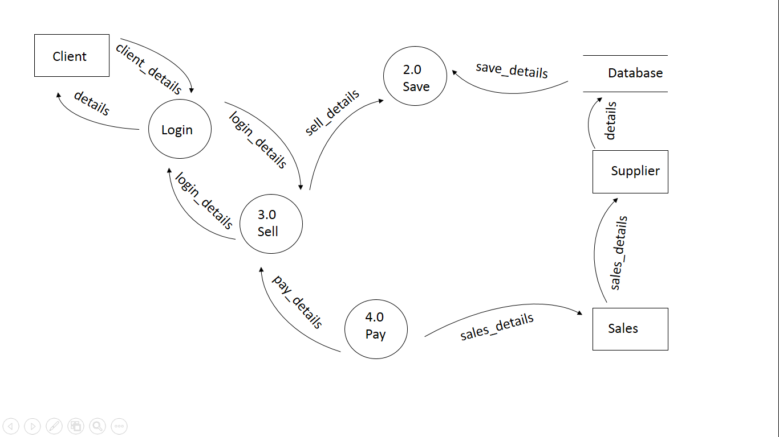

|  |  |
| --- | --- |
| **Description** | **Mark** |
| A mark for each correct error identified | 1-4 |
| Total | 4 |
| Sample answers may include   1. Sales entity to Supplier entity 2. Supplier entity to database data store 3. Login process does not have a number 4. Sell process is sending back to Login process a data flow 5. Pay process is sending back to Sell process a data flow 6. Pay is a miracle with data only coming out. 7. Save is a black hole with data only coming in 8. Save data flow coming out of Database | |

**Question 15 (4 marks)**

Below is an example of an Entity Relationship diagram. Label the following on the diagram.

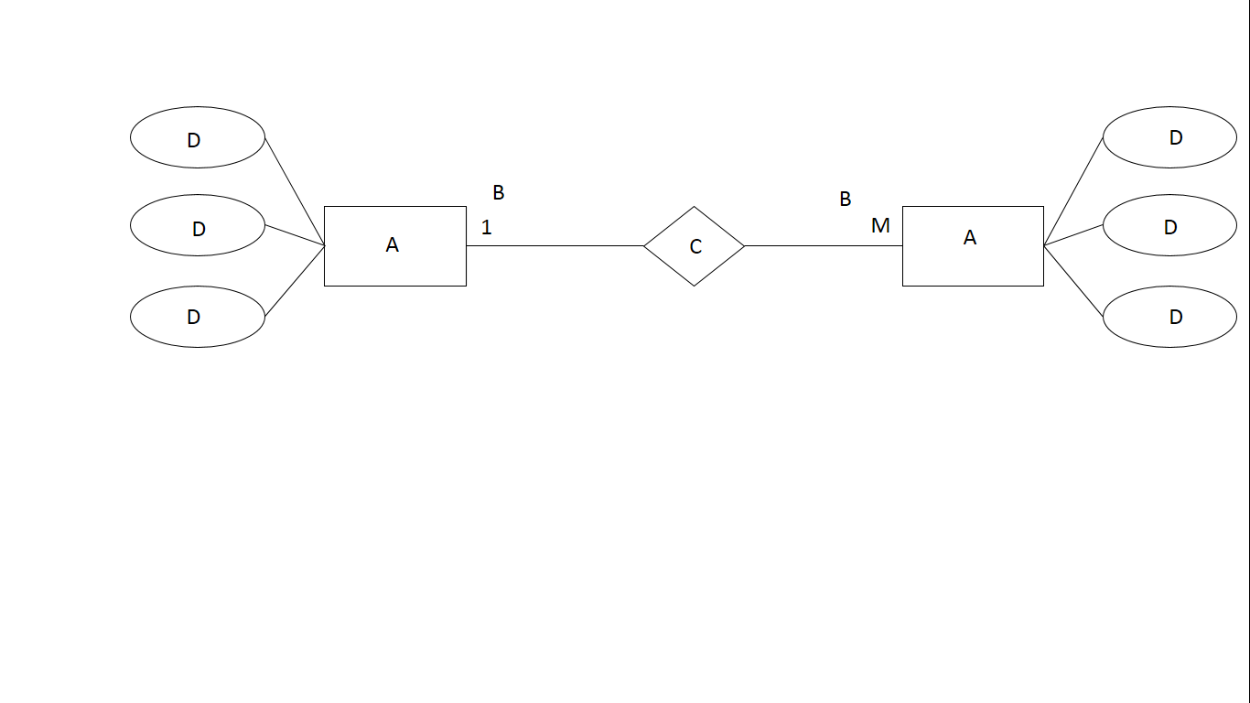

|  |  |
| --- | --- |
| **Description** | **Mark** |
| Entity is labelled correctly | 1 |
| Cardinality is labelled correctly | 1 |
| Relationship is labelled correctly | 1 |
| An attribute is labelled correctly | 1 |
| Total | 4 |

**Question 16 (3 marks)**

Cache is a special high-speed memory area on the CPU.

1. Outline the purpose of cache. (1 mark)

|  |  |
| --- | --- |
| **Description** | **Mark** |
| Outlines correctly the purpose of cache | 1 |
| Total | 1 |
| Sample answer  The purpose of cache is to store program instructions that are frequently re-referenced by software during operation. | |

1. Describe the term ‘cache hit’. (2 marks)

|  |  |
| --- | --- |
| **Description** | **Mark** |
| Detailed description of the term cache hit | 2 |
| Limited description of the term cache hit | 1 |
| Total | 2 |
| Sample answer  A cache hit is a state in which data requested for processing by a component or application is found in the cache memory as opposed to a cache miss when it is not found in cache memory. | |

**Question 17 (3 marks)**

A company has asked you to discuss **three** physical preventative maintenance measures you could introduce to keep their server equipment safe.

|  |  |
| --- | --- |
| **Description** | **Mark** |
| Correctly discusses a physical preventative maintenance measure | 1-3 |
| Total | 3 |
| Sample answers   1. Install air conditioning – servers can become very hot and it is important that they do not overheat. 2. Install a UPS – this will allow the server to shut down correctly in the case of a power shortage. 3. Locked door with appropriate access – the server has important information and should only be accessed by the proper personnel.   Accept other reasonable answers but they need to discuss why. | |

**Question 18 (3 marks)**

A database administrator has tried to explain to the owner of a company that it is important to increase data integrity by reducing data redundancy. Explain using examples why this is a good idea.

|  |  |
| --- | --- |
| **Description** | **Mark** |
| Detailed explanation why it is a good idea | 2 |
| Limited explanation why it is a good idea | 1 |
| Use examples | 1 |
| Total | 3 |
| Sample answer  Data redundancy – is the undesirable duplication of data, within a database. If you have data that is replicated time and time again, used all over the place, with multiple sources, then it is redundant data. These duplications can occur through spelling mistakes, incorrect normalisation, also calculated fields. Such as age as a field where this will need to be changed each year it would be best to have a calculated field that takes the DOB and today’s date and works it out.  Data integrity – the reliability of data. If you have reliable data, it has integrity. Reliable data is accurate data | |

**Question 19 (3 marks)**

The following email was sent to a colleague.

Dear Joe

I am very UPSET about the spilt coffee in the staff room today. I know you said you were sorry HOWEVER that is not the point. YES I KNOW that you cleaned it up but it should not have occurred. I think you OWE everyone an apology and SHOULD BUY COFFEES FOR EVERYONE TOMORROW.

JACK

Describe whether Jack has followed an acceptable level of digital communication etiquette through this email.

|  |  |
| --- | --- |
| **Description** | **Mark** |
| Highly detailed description of Jack not following acceptable etiquette | 3 |
| Detailed description of Jack not following acceptable etiquette | 2 |
| Limited description of Jack not following acceptable etiquette | 1 |
| Total | 3 |
| Sample answer  Digital etiquette is about using manners online. This email has a lot of aggression and the use of capital letters throughout is considered equal to shouting. It would be considered rude and concerning as it could be considered intimidation or harassment as Joe had already apologised as indicated in the email. It would be considered not acceptable etiquette. | |

**Question 20 (6 marks)**

The following is a poorly designed database form to capture personal details.

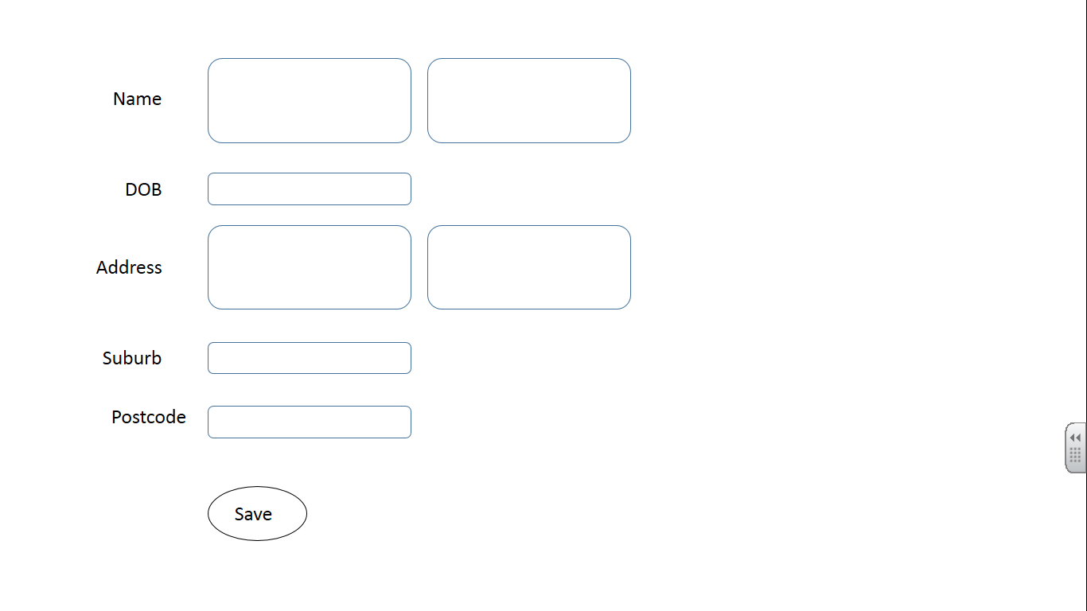

Use your knowledge of design considerations and design a new form to enhance useability of the visual interface for this database form. Annotate how the features you have included enhance useability.

|  |  |
| --- | --- |
| **Description** | **Mark** |
| Design features |  |
| An excellent database form with many features that enhance useability | 3 |
| A database form with 2+ features that enhance useability | 2 |
| A basic database form with 1-2 features that enhance useability | 1 |
| Annotations |  |
| Highly detailed annotations indicating enhancement for useability | 3 |
| Detailed annotations indicating enhancement for useability | 2 |
| Limited annotations indicating enhancement for useability | 1 |
| Total | 6 |

**Section Two: Extended answer 60% (79 Marks)**

**Question 21 (29 marks)**

1. Tabletop Events Corporation have begun planning their new web application. The application needs to go live at the end of September. Outline **three** aspects they need to take into account in order to meet the deadline. (3 marks)

|  |  |
| --- | --- |
| **Description** | **Mark** |
| Outline an aspect that would be required to meet the deadline (mark for each logical answer) | 1-3 |
| Total | 3 |
| Sample answer  They need to ensure that they have the budget to hire people and purchase the required equipment to host and software to run the web application.  They need to ensure that they have the expertise available to design and create the web application.  They need to ensure that they have all the information required to populate the application including any backend database connection.  Answers may vary. | |

1. Tabletop Events have realised that there are a number of tasks that need to be undertaken. These include: creating survey, screen design, integration with the database, etc. Describe a tool that could be used to keep track of these tasks. (2 marks)

|  |  |
| --- | --- |
| **Description** | **Mark** |
| Detailed description of tool | 2 |
| Limited description of tool | 1 |
| Total | 2 |
| Sample answer  The company could use Case tools that include a GANTT chart which will enable them to keep track of the tasks, milestones, personnel working on the project, budget and the timeframes. | |

1. Use the source booklet to complete the unfinished Context diagram for the Tabletop Events Corporation system below. (8 marks)

|  |  |
| --- | --- |
| **Description** | **Mark** |
| Entities – Client and catering company | 1-2 |
| Process name of Tabletop Events Corporation Function System (needs to be logical) | 1 |
| Data flow to the Catering Company | 1 |
| Data flows to and from the client |  |
| Personal details, function date, people # from client and available venues to client | 1 |
| Username and password details, deposit details, CC details from client and contract and receipt details to client | 1 |
| Menu details from client | 1 |
| Invoice details and receipt to client and payment details from client | 1 |
| Total | 8 |
| Sample answer  Data flows can be grouped and names may vary slightly | |

1. Use the source booklet to create the Level 0 Data Flow Diagram (DFD) for the system below. (16 marks)

|  |  |
| --- | --- |
| **Description** | **Mark** |
| Correct use of Yourdon/DeMarco notation | 1 |
| Entities – Client and Catering company | 1-2 |
| Data stores – enquiry database and bookings database | 1-2 |
| Processes – Check venue, Create login, Choose menu and Create invoice | 1-4 |
| Data flow to the Catering company entity | 1 |
| Data flows to and from data stores |  |
| Enquiry details and saved enquiry details to and from the enquiry data store | 1 |
| Booking details and menu details to the booking database | 1 |
| Data flow to and from the client entity |  |
| Personal details, function date, people # from client and available venues to client | 1 |
| Username and password details, deposit details, CC details from client and contract and receipt details to client | 1 |
| Menu details from client | 1 |
| Invoice details and receipt to client and payment details from client | 1 |
| Total | 16 |
| Sample answer  Names of flows and processes may vary | |

**Question 22 (16 marks)**

Refer to the image in the source booklet and answer the following questions.

1. Describe the issue of using a spreadsheet instead of a database to create an invoice.

(3 marks)

|  |  |
| --- | --- |
| **Description** | **Mark** |
| Highly detailed description of the issue of using a spreadsheet for an invoice | 3 |
| Detailed description of the issue of using a spreadsheet for an invoice | 2 |
| Limited description of the issue of using a spreadsheet for an invoice | 1 |
| Total | 3 |
| Sample answer  Using a spreadsheet would mean that each invoice would have to be recreated and the details of the client details would have to be entered and if the client has more than one event booking an invoice would need to be for each event. There will be no way of using the data to send marketing emails. Mistakes could be made if the client details are reentered more than once. There is a mistake in the form GUEST NO; the ; should be a : and this would be replicated in each invoice, etc.  Answers will vary and may include of using a database, etc. | |

1. This invoice has a number of calculations using different formulas and functions. Write the most efficient formulas and functions for the following cells. (13 marks)
   1. C21
   2. C23
   3. C25
   4. C11

|  |  |
| --- | --- |
| **Description** | **Mark** |
| = SUM(C11:C20) (1 mark for =SUM and 1 mark for (C11:C20)) | 1-2 |
| =C21 * 10% (1 mark for =C21 and 1 mark for the *10% (% part may vary)) | 1-2 |
| =C21+C23+C24 (1 mark for each cell reference) | 1-3 |
| =VLOOKUP(A11,Lookup!A2:C6,3,FALSE)*C8 (1 mark for =VLOOKUP, 1 mark for A11, 1 mark for Lookup!A2:C6 (must have the Lookup! as this is the worksheet reference. May include absolute reference) 1 mark for 3, 1 mark for FALSE for exact match and 1 mark for *C8 (this is the number of guests) | 1-6 |
| Total | 13 |

**Question 23 (25 marks)**

Use the information in the source booklet to answer this question

1. Using your understanding of databases, complete the following for the Client table.

(4 marks)

|  |  |
| --- | --- |
| **Description** | **Mark** |
| Each correct column 1 mark each | 1-4 |
| Total | 4 |
| Sample answer  The answers may vary but must be logical. Some students may put text for ClientContactNo as they tend to use spaces etc. A mask could also be used to do this.   |  |  |  |  | | --- | --- | --- | --- | | Field Name | Data Type | Description | Other detail | | ClientUserName | Text | Client User Name | Must be unique | | ClientPassword | Text | Client Password | Must include Capital, number and symbol with a minimum of 8 characters | | ClientFirstname | Text | Client First Name | Capital at beginning | | ClientSurname | Text | Client Surname | Capital at beginning | | ClientAddress | Text | Client Address | Capital at beginning | | ClientContactNo | Number | Client Contact Number | Mandatory | | ClientEmail | Text | Client Email Address | Mandatory | | |

1. Describe what would be needed to create a working database for the tables listed. (3 marks)

|  |  |
| --- | --- |
| **Description** | **Mark** |
| Highly detailed description of what is required | 3 |
| Detailed description of what is required | 2 |
| Limited detailed description of what is required | 1 |
| Total | 3 |
| Sample answer  Firstly, the tables need to be in 3NF. This is not the case at present because of the Address field in both the Client and Catering table as there is no separation between street, suburb or postcode. There are no foreign keys in the booking table. Once these are sorted then in the database the primary key in Client and Catering tables must be present in the Booking Table.  Answers may vary | |

1. The database administrator has stated that some of the fields are not atomic. Using your understanding of the term atomicity, identify a non-atomic field in the Catering table and describe what is required in order for this to be sorted. (3 marks)

|  |  |
| --- | --- |
| **Description** | **Mark** |
| Highly detailed description of what is required | 3 |
| Detailed description of what is required | 2 |
| Limited detailed description of what is required | 1 |
| Total | 3 |
| Sample answer  Atomicity is the use of a single piece of data in a field. CateringAddress is non-atomic field as it combines all parts of an address. It should be broken down into Street No, Street name, Suburb, Postcode, State, Country in order for it to be completely atomic.  Answers may discuss more than one contact number etc. | |

1. Using your understanding of how databases work, complete the Entity Relationship (ER) Diagram for this database, ensuring you resolve all many to many relationships. Include Primary keys, Foreign keys, cardinality, relationships using Chen’s notation. (12 marks)

|  |  |
| --- | --- |
| **Description** | **Mark** |
| Entities – Client, Booking and Catering (1 mark for each) | 1-3 |
| Cardinality – 1:M and M:1 (1 mark for each) | 1-2 |
| Relationship – makes and has (1 mark for each, name may vary) | 1-2 |
| Primary keys – ClientUserName, BookingID and CateringID | 1-3 |
| Foreign keys – ClientUserName, CateringID | 1-2 |
| Total | 12 |
| Sample Answer | |

1. The database manager has suggested that documentation be created to help use the finished database. Describe **three** features that user documentation should include. (3 marks)

|  |  |
| --- | --- |
| **Description** | **Mark** |
| Highly detailed description of three features that user documentation should include | 3 |
| Detailed description of 2-3 features that user documentation should include | 2 |
| Limited description of 1-3 features that user documentation should include | 1 |
| Total | 3 |
| Sample answer  Answers may vary but must be logical.   1. Should be easy to follow and use images to indicate what to press, etc. 2. Should have troubleshooting section for common errors 3. Should have an index to find what is required quickly | |

**Question 24 (9 marks)**

Tabletop Events have had some issues with the security of their database. They have been told not to worry about it as no one is going to hack into their system. You disagree with this and have decided to describe the legal requirements the company must follow.

1. Describe the legal requirements for the collection of information for citizens that organisations must follow.

|  |  |
| --- | --- |
| **Description** | **Mark** |
| Highly detailed description of the legal requirements for the collection | 3 |
| Detailed description of the legal requirements for the collection | 2 |
| Limited description of the legal requirements for the collection | 1 |
| Total | 3 |
| Sample answer   * an organisation may only solicit and collect personal information that is reasonably necessary for one or more of its functions or activities * in addition to the above requirements, they may only solicit and collect sensitive information if the individual consents to the sensitive information being collected, unless an exception applies by way of a government agency | |

1. Describe the legal requirements for the storage of information for citizens that organisations must follow.

|  |  |
| --- | --- |
| **Description** | **Mark** |
| Highly detailed description of the legal requirements for the collection | 3 |
| Detailed description of the legal requirements for the collection | 2 |
| Limited description of the legal requirements for the collection | 1 |
| Total | 3 |
| Sample answer  Once the information has been collected an organisation should design personal information security measures with the aim to:   * prevent the misuse, interference, loss or unauthorised accessing, modification or disclosure of personal information * detect privacy breaches promptly * be ready to respond to potential privacy breaches in a timely and appropriate manner. | |

1. Describe the legal requirements for the use of information for citizens that organisations must follow.

|  |  |
| --- | --- |
| **Description** | **Mark** |
| Highly detailed description of the legal requirements for the collection | 3 |
| Detailed description of the legal requirements for the collection | 2 |
| Limited description of the legal requirements for the collection | 1 |
| Total | 3 |
| Sample answer   * An organisation must take reasonable steps to protect personal information it holds from misuse, interference and loss, as well as unauthorised access, modification or disclosure. * Where an APP entity no longer needs personal information for any purpose for which the information may be used or disclosed under the APPs, the entity must take reasonable steps to destroy the information or ensure that it is de-identified. This requirement applies except where: | |